**Joshua Ajiboye’s Pack**

**No. 1**

Shopping during the sales can sometimes be very confusing. With discounted prices at 10%, 20%, 50% or even 70%!

For this challenge you are going to write a function that prompts the user to enter a price in pounds (e.g. £90) and a discount rate to apply (e.g. 20%).

Your program will then calculate and display the discounted price.

**No. 2**

Write a program that accepts a sentence and calculate the number of upper-case letters and lower-case letters.

Suppose the following input is supplied to the program:

Hello world!

Then, the output should be:

UPPER CASE 1

LOWER CASE 9

**Hints:**

In case of input data being supplied to the question, it should be assumed to be a console input.

**No. 3**

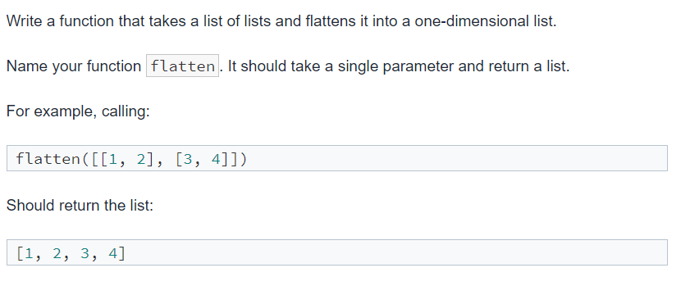

**No. 4**

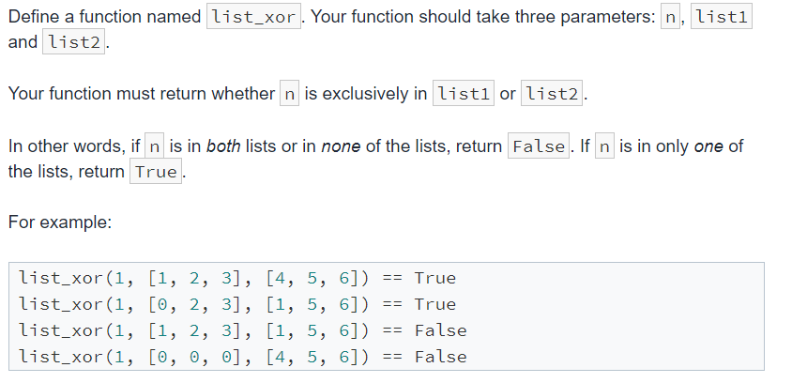

**No. 5**

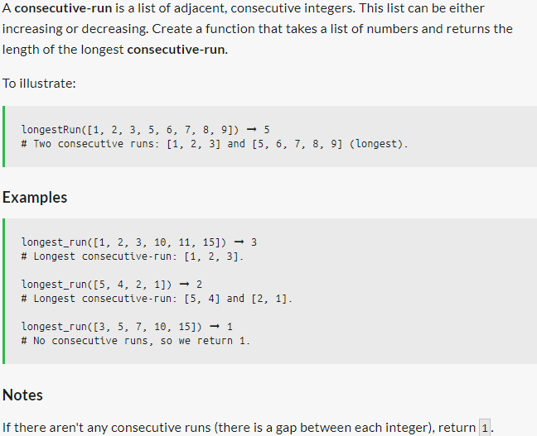

**No. 6**

